**Annexure-I**

**SMART WORKOUT**

**A Mini-Project Report**

**Under**

**Project Workshop**

***Submitted by***

**NAME OF THE CANDIDATE**

**Payal Ninawe**

**Paranjay Panwar**

***Under The Guidance Of***

**Prof. Ratnesh Chaturvedi**

***in partial fulfillment for the award of the degree***

***of***

**Bachelor Of Technology**

**IN**

**BRANCH OF STUDY**

**Computer Science**

**at**

**Mukesh Patel School Of Technology Management And Engineering**

**April, 2015**

**CERTIFICATE**

This is to certify that the project entitled “WORKOUT” is the bonafide work carried out by Paranjay Panwar of B.Tech (Computer Engineering), MPSTME (NMIMS), Mumbai, during the IX trimester of the academic year 2014-15, in partial fulfillment of the requirements for the award of the Degree of Bachelors of Technology as per the norms prescribed by NMIMS. The mini-project work has been assessed and found to be satisfactory.

Prof. Ratnesh Chaturvedi

Internal Mentor

_______________________ ________________________

Examiner 1 Examiner 2

________________________

Dean

Dr. D.J. Shah

**DECLARATION**

We, Paranjay Panwar and Payal Ninawe , Roll No. _E023 and E018_ B.Tech (Computer Engineering), IX trimester understand that plagiarism is defined as anyone or combination of the following:

1. Un-credited verbatim copying of individual sentences, paragraphs or illustration (such as graphs, diagrams, etc.) from any source, published or unpublished, including the internet.
2. Un-credited improper paraphrasing of pages paragraphs (changing a few words phrases, or rearranging the original sentence order)
3. Credited verbatim copying of a major portion of a paper (or thesis chapter) without clear delineation of who did wrote what. (Source: IEEE, The institute, Dec. 2004)
4. I have made sure that all the ideas, expressions, graphs, diagrams, etc., that are not a result of my work, are properly credited. Long phrases or sentences that had to be used verbatim from published literature have been clearly identified using quotation marks.
5. I affirm that no portion of my work can be considered as plagiarism and I take full responsibility if such a complaint occurs. I understand fully well that the guide of the seminar/ project report may not be in a position to check for the possibility of such incidences of plagiarism in this body of work.

Signature of the Student: <all group members>

Name: Paranjay Panwar and Payal Ninawe

Roll No. E023 and E018

Place: Mumbai

Date: 21/04/2015

**ACKNOWLEDGEMENT**

We are really grateful because we managed to complete our Implementation of Technology assignment within the time given by our teacher Mr.Ratnesh Chaturvedi. This project could not be completed without the effort and co-operation from our group members, Paranjay Panwar and Payal Ninawe. We also sincerely thank our teacher Ms. Mr.Ratnesh Chaturvedi.for the guidance and encouragement in finishing this project and also for guiding us throughout. Last but not the least, we express our gratitude to our friends and respondents for their support and willingness.

**ABSTRACT**

Get in the best shape of your life with thousands of free workouts and premium training programs that help you achieve your goals

Your certified personal trainers guide you through exercises with timed, step-by-step audio, photo and video instructions complete with encouragement! Whether you’re doing bodyweight workouts at home or lifting weights at the gym, Workout Trainer is the ultimate fitness companion. You can also choose your area of focus and use the app to get a six pack, lose weight, improve your running, practice yoga, and more.

Workout is ideal for people who want to get in shape without using any exercise equipment.

**TABLE OF CONTENT**

|  |  |  |
| --- | --- | --- |
| **Chapter. No.** | **Topic** | **Page No.** |
|  |  |  |
| 1 | Introduction | 09 |
| 2 | Push-Up | 11 |
| 3 | Pull-Up | 14 |
| 4 | Squats | 17 |
| 5 | Sit-Up | 19 |
| 6 | Pedometer | 21 |
|  | Limitations | 22 |
|  | Conclusion | 23 |

**CHAPTER 1**

**WORKOUT**

**1.1 INTRODUCTION**

SMART WORKOUT app is the ideal companion as it turns your smartphone into your PERSONAL TRAINER. Use the app to strengthen your muscles anytime, anywhere. This classic strength move doesn’t require a gym membership or equipment. Do your body some good and let Runtastic help you live a healthier, fitter life. A scientifically developed training plan guides you towards your goal, always keeping your personal fitness level in mind. Plus, no need to count your reps: The proximity sensor in your smartphone/tablet reliably counts all your exercises.

1.2 APP FEATURES & BENEFITS:

* Accurate count of completed push-up repetitions using proximity sensor or by your nose touching the display

* Three individually adaptable levels based on scientifically developed training plan to reach 100 push-ups

* Automatic countdown timer for your rest between exercise sets

* Personal records & exercise statistics (i.e. monthly or yearly stats).

* Chronometer to asses your workout time and relaxation time.

**Contents**

* PUSH-UPS
* PULL-UPS
* SIT-UPS
* SQUATS
* PEDOMETER

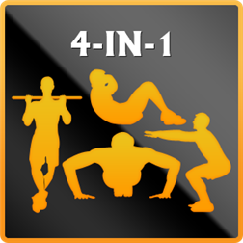

**App Interface**

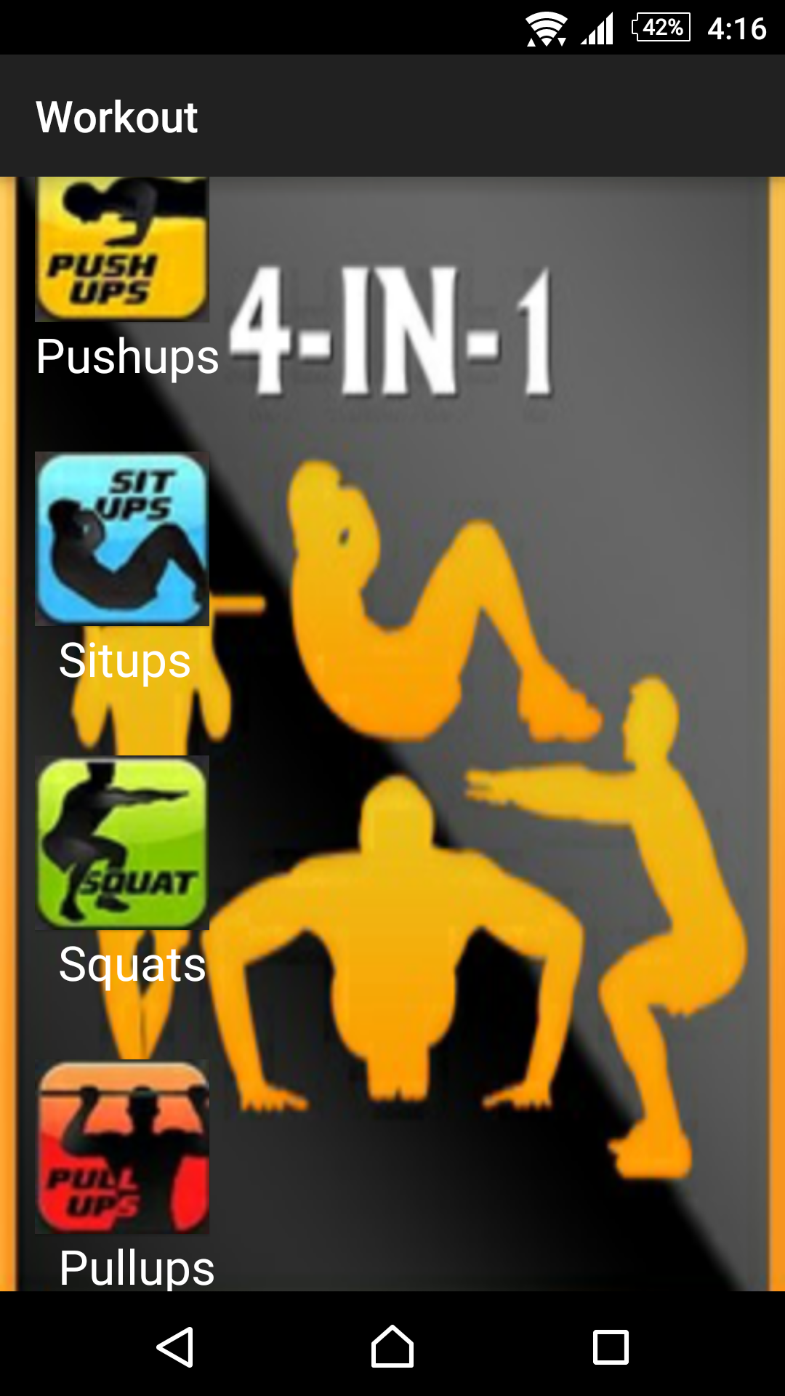

CHAPTER 2

PUSH-UPS

* Proximity sensor Counting
* Enter training data manually
* Graphs and Statistics
* Training mode
* Training data back up and restore
* Training Notification
* Chronometer for your workout

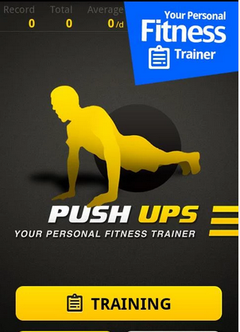

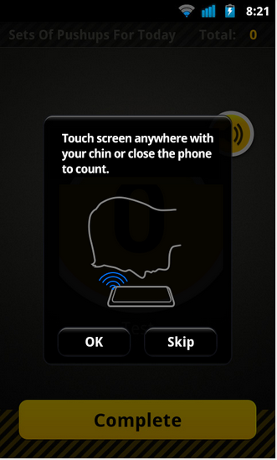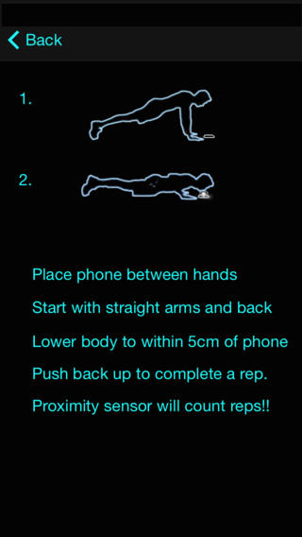

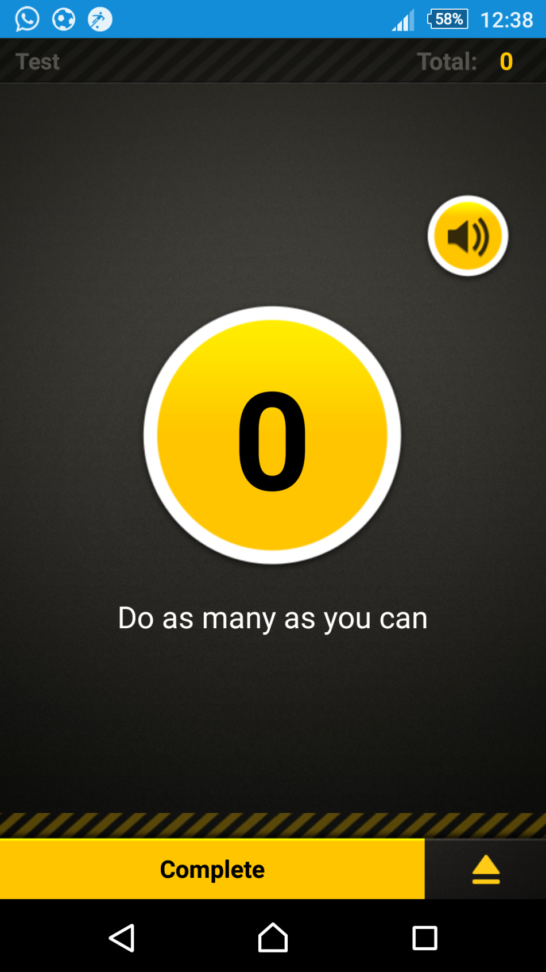

Chapter 3

PULL-UPS

* Proximity sensor Counting
* Enter training data manually
* Graphs and Statistics
* Training mode
* Chronometer for your workout
* Training data back up and restore
* Training Notification

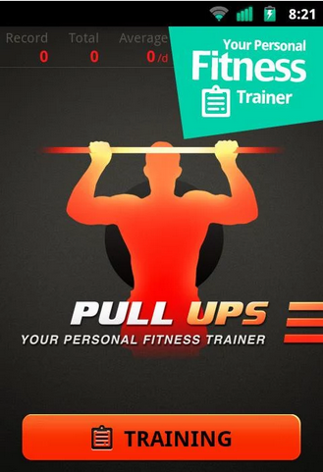 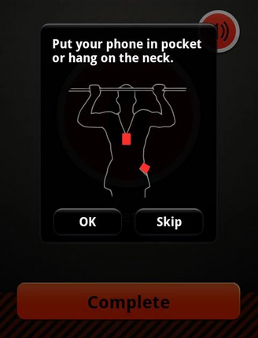

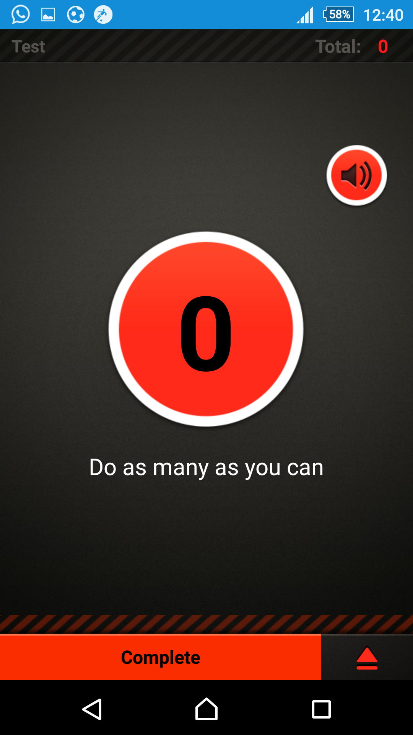

CHAPTER 4

SQUATS

* Proximity sensor Counting
* Enter training data manually
* Chronometer for your workout
* Graphs and Statistics
* Training mode
* Training data back up and restore
* Training Notification

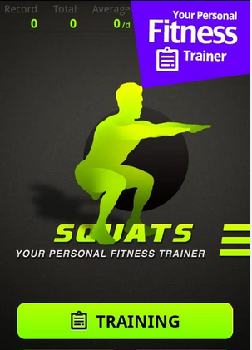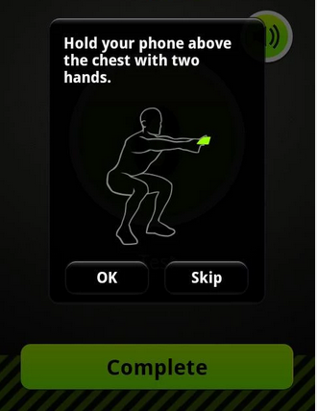

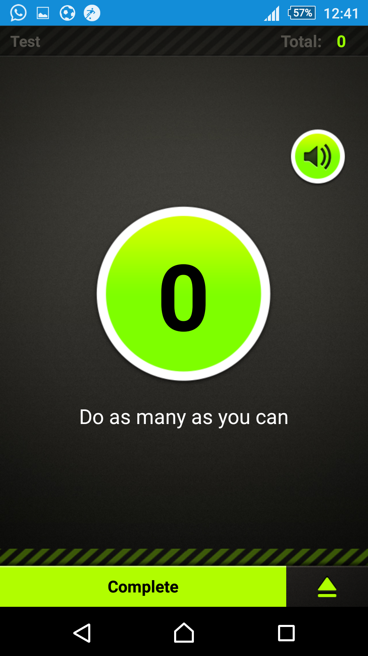

CHAPTER 5

SIT-UPS

* Proximity sensor Counting
* Chronometer for your workout
* Enter training data manually
* Graphs and Statistics
* Training mode
* Training data back up and restore
* Training Notification

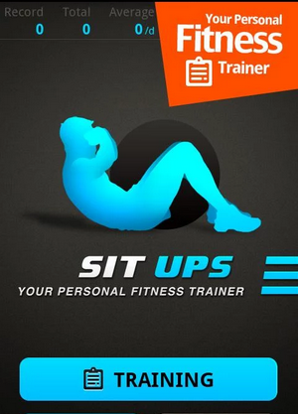

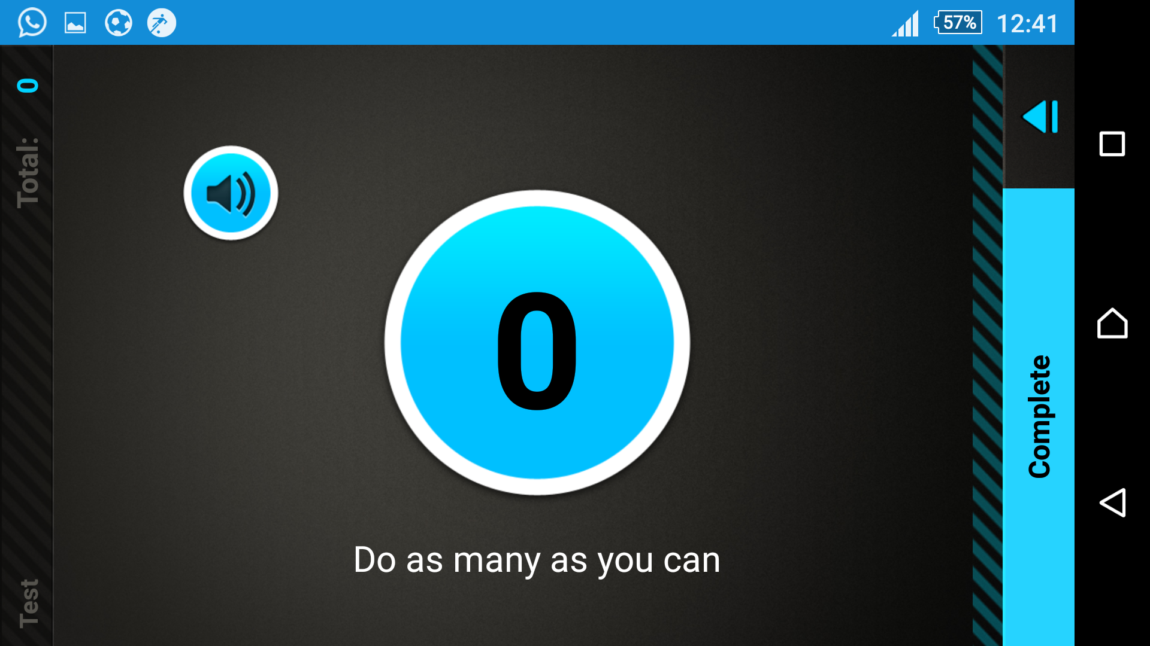

CHAPTER 6

PEDOMETER

* Track and analyze your performances
* monitor your progress
* Store all training data in your personal workout diary
* Chronometer for your workout
* Keep track of calories burned
* Keep track of average training speed
* Keep track of running pace

**Limitations of the App**

* A device handling case is required without which some of the features may not work efficiently.
* Some error might come while counting as the app varies from device to device.
* The distance required by the proximity sensor has to be kept in mind(varies from device to device).
* The distance required by the gravity sensor has to be kept in mind(varies from device to device).

**CONCLUSION**

To conclude, we’d like to thank everyone who has helped us along the way of turning this app idea into a reality. Our guiding Faculty, Prof. Ratnesh Chaturvedi, was supportive right from the start till the end.

As for the application itself, every aspect is in working condition and has been tested several times on different android smart phones. As and when our operational knowledge of developing applications improves, the application will also improve and evolve to match its prevailing competitors in the workout application market.

**Contact us:**

[Payal.ninawe@gmail.com](mailto:Payal.ninawe@gmail.com)

[Paranjay.psp@gmail.com](mailto:Paranjay.psp@gmail.com)

**REFERENCES**

* Stackoverflow.com
* Androidcookbook.com
* Androidhype.com
* Developers.google.com